Vivekanand Education Society's Institute of Technology

Department of Computer Engineering
Group No.: 16
Date :- 11/08/2025

Project Synopsis Template (2025-26) - Sem VII

Shikshak Sarthi
Automated Faculty Appraisal & Development System
Dr. Mrs. Rohini Temkar
Assistant Professor, Department of Computer Engineering

Darshan Khapekar Aadil Shah Mayuresh Gujare
V.E.S.I.T V.E.S.I.T V.E.S.I.T d2022.darshan.khapekar@ves.ac.in 2022.aadil.shah@ves.ac.in 2022.mayuresh.gujare@ves.ac.in

Abstract
The Automated Faculty Appraisal & Development System is a web-based platform designed to streamline and modernize faculty self-appraisal processes. It addresses the inefficiencies of traditional paper-based evaluation by offering a secure, real-time, and user-friendly solution. The system captures diverse faculty activities, including research publications, events, seminars, projects, and lectures, while ensuring data confidentiality through secure authentication. With an integrated admin panel, university administrators can efficiently view, sort, and download appraisal data in PDF format. This digital transformation fosters transparency, enhances decision-making, and aligns with the Paperless India initiative.

Introduction
Faculty self-appraisal plays a critical role in higher education by ensuring quality, recognizing contributions, and promoting professional growth. Traditional appraisal methods often involve cumbersome paperwork, slow processing, and limited transparency. This project introduces a robust digital platform to manage faculty appraisal activities effectively. The proposed solution integrates automatic research tracking, real-time activity logging, and centralized data access, enabling faculty and administrators to interact seamlessly. It not only minimizes administrative burdens but also supports sustainability goals by eliminating paper-based records.

Problem Statement
In many higher education institutions, faculty appraisal relies on manual documentation and fragmented record-keeping. This process is time-consuming, error-prone, and lacks transparency. Key issues include:

- Cumbersome paperwork and delayed updates of faculty activities.
- Difficulty in tracking research outputs and academic contributions.
- Limited accessibility of data for timely decision-making.
- Inefficient administrative processes, making sorting and evaluating data challenging.
- Security concerns in storing and sharing sensitive faculty information.

Proposed Solution
The proposed system is a real-time, secure, web-based self-appraisal management platform that enables:
- Faculty members log and update their research publications, event participation, seminars, projects, and lectures.
- Automatic tracking of research publications similar to Google Scholar’s functionality.
- Secure authentication for faculty and administrators with role-based access.
- An admin panel to view, sort, and download appraisal data in PDF format.
- Centralized database for storing all records securely.
- Client-side and server-side validation to ensure data accuracy.
- This system aims to reduce paperwork, improve efficiency, and provide a transparent appraisal process aligned with modern academic standards.

Methodology / Block Diagram
Step-wise Methodology:
- User Registration & Authentication – Faculty and admins create accounts with secure login credentials.
- Activity Logging – Faculty enter data into the self-appraisal form for research, events, seminars, projects, and lectures.
- Automatic Research Tracking – The system fetches and updates publication records from integrated APIs (similar to Google Scholar).
- Data Storage – All entries are stored securely in a centralized database.
- Admin Access & Review – Admin panel allows viewing, sorting, filtering, and downloading appraisal records.
- PDF Generation – Admins can export records in PDF format for official documentation.
- Real-Time Updates – Both faculty and admins have instant access to the latest records.
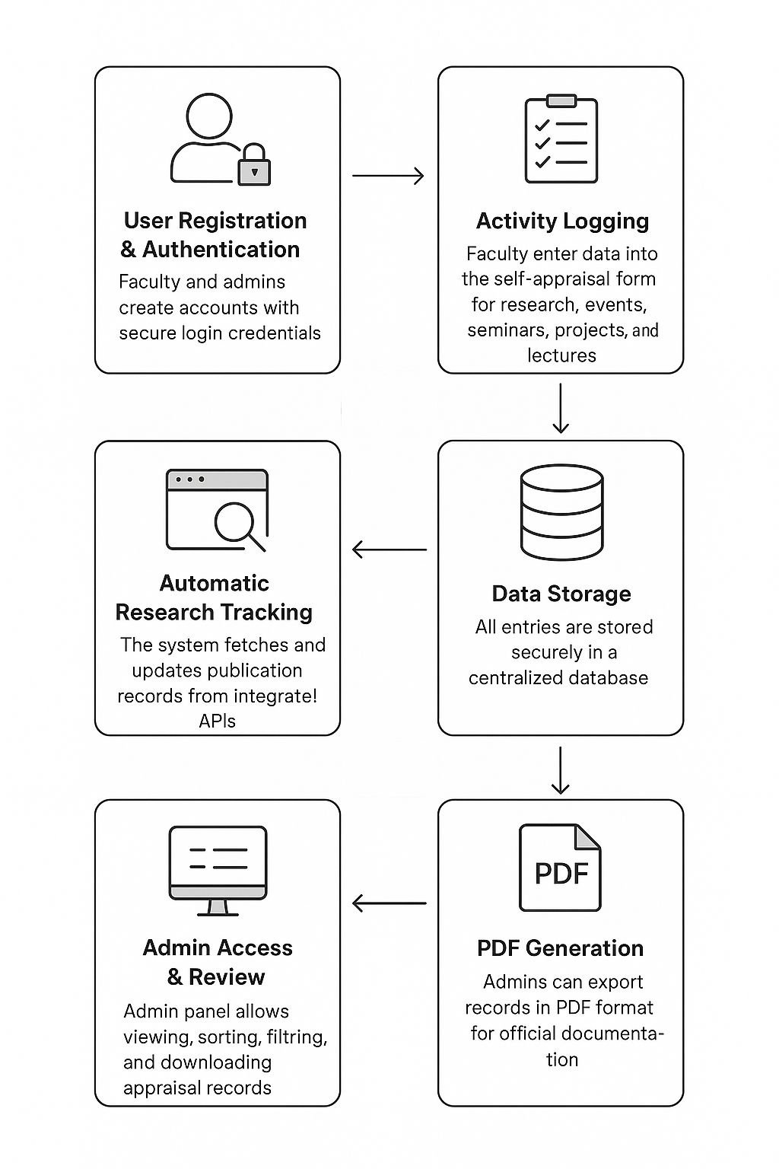

Hardware , Software and tools Requirements
Hardware Requirements
- OS: Windows 10 or above / Linux
- Processor: Quad-core or higher
- RAM: 4 GB minimum
- Storage: 250 GB+ HDD / SSD preferred
Software Requirements
- Web Browser: Chrome, Firefox, or Edge
- IDE: Visual Studio Code
- Backend: Python (Flask)
- Frontend: HTML5, CSS3, JavaScript, React
- Database: Firebase
- API Testing: Postman
- Version Control: Git & GitHub

Proposed Evaluation Measures
The system’s effectiveness will be evaluated based on:
- Performance: Response time for form submissions and data retrieval.
- Accuracy: Correct and complete capture of faculty activities.
- Security: Successful prevention of unauthorized access and data breaches.
- Usability: User satisfaction ratings and ease of navigation.
- Scalability: Ability to handle increasing numbers of users and records without degradation.
- Reliability: System uptime and error rates during usage.

Conclusion
The Automated Faculty Appraisal & Development System modernizes the faculty appraisal process by eliminating paperwork, enhancing transparency, and providing real-time insights into academic contributions. Its secure architecture ensures data confidentiality, while the intuitive interface facilitates adoption by faculty and administrators alike. By incorporating automated research tracking and centralized record management, the platform fosters a culture of continuous improvement in higher education institutions and supports the Paperless India initiative.

References
[1] S. Shah, “Evaluation of Overall Performance of Faculty Members by Using Self-Assessment Method,” Journal of Universal Research in Education & Technology, Dec. 2020. [Online]. Available: https://www.researchgate.net/publication/348877966_Evaluation_of_Overall_Performance_of_Faculty_Members_by_Using_Self-Assessment_Method

[2] A. Anurika, S. Sengupta, S. Singh, “A Study on Performance Appraisal in Higher Education: A Bibliometric Analysis and ANOVA Approach,” Mar. 2025. [Online]. Available: https://www.researchgate.net/publication/390158157_A_Study_on_Performance_Appraisal_in_Higher_Education_A_Bibliometric_Analysis_and_ANOVA_Approach

[3] “Teachers’ Competency Self-Evaluation Framework,” Central Board of Secondary Education (CBSE), India. [Online]. Available: https://www.cbse.gov.in/cbsenew/documents//Teachers%20Competency%20Self%20Evaluation%20Final.pdf

[4] “Faculty Performance Appraisal & Development System (FPADS),” Deogiri Institute of Architecture & Management (example institutional policy PDF). [Online]. Available: https://www.dsatm.edu.in/naac/AQAR%202023/Criteria%206/6.3.5/Faculty%20Performance%20Appraisal.pdf

[5] “Performance Appraisal System in Academics at Professional Institutions,” International Journal of Advanced Engineering & Management (IJAEM) — PDF. [Online]. Available: https://ijaem.net/issue_dcp/Performance%20Appraisal%20System%20in%20Academics%20at%20Professional%20Institutions.pdf

[6] “Performance Appraisal of Private University Teachers in West Bengal,” IOSR Journal of Humanities and Social Science, 2024. [Online]. Available: https://www.iosrjournals.org/iosr-jhss/papers/Vol.30-Issue3/Ser-7/L3003077481.pdf

[7] “A Study on Performance Management and Appraisal in Higher Education” (NERJ). [Online]. Available: https://nerj.org/uploads/archives/93aefaca-e5c0-412b-922a-6f97c8120091.pdf

[8] “An Interventional Study on Self Assessment of Teaching Practices Among Medical Faculty,” IJCMAAS, Feb. 2017. [Online]. Available: https://www.ijcmaas.com/images/archieve/IJCMAAS_FEB_2017_VOL13_ISS3_07.pdf

[9] “Performance Appraisal of University Faculty in India: A Study of …” (Gujrat or other institution report). [Online]. Available: https://gjust.ac.in/portal/upload/827f4363-3f64-4484-a74a-c0f0f79ccc0b.pdf

[10] “Annual Self Appraisal Report (ASAR)” — Bharati Vidyapeeth / Sample Annual Self Appraisal (NAAC related). [Online]. Available: https://yclc.bharatividyapeeth.edu/media/pdf/NAAC_2024/6-3-4-_Annual_Self_Apprisal_Report_060524.pdf

[11] “Self Appraisal Form (Sample Copy)” — Atmiya University NAAC self-appraisal PDF. [Online]. Available: https://naac.atmiyauni.ac.in/upload/assessment/U0967_631_AI_Self_Appraisal_70b1733226887.pdf

[12] “Faculty Performance Appraisal – K.Ramakrishnan College of Technology” (FPAS sample with Scopus/WoS instructions in annexure). [Online]. Available: https://krct.ac.in/ktgadmin/assets/php/pdf/1575709633.pdf

[13] “Self-Appraisal Form 2023–24” — Jamal Mohamed College (sample institutional form). [Online]. Available: https://jmc.edu/images/files/Self-Appraisal-Form-2023-2024.pdf

[14] “Online Faculty Self-Appraisal Report System,” IRJMETS (April 2025) — PDF. [Online]. Available: https://www.irjmets.com/uploadedfiles/paper//issue_4_april_2025/72381/final/fin_irjmets1744611526.pdf

[15] “Performance Management System in Higher Education in India” — IJMER / JETIR (open PDF). [Online]. Available: https://s3-ap-southeast-1.amazonaws.com/ijmer/pdf/volume10/volume10-issue10%281%29/8.pdf

